

**American International University-Bangladesh (AIUB)**

Faculty of Science and Technology

Department of Computer Science

CSC 3224: Computer Graphics

Project Report

**Project name:** **River Side City View**

Section: N

Group member:

|  |  |
| --- | --- |
| NAME | ID |
| REDWANUL HAQUE IFTY | 19-39472-1 |
| Tanvir Tanjum Nafis | 18-39156-3 |
| Hossain Ahmed Patwary | 18-39266-3 |
| Shopnil, MD. Samiul Maleck | 18-36540-1 |
| MD SAFAYET HOSSAIN | 18-37249-1 |

.

**Feature/ Component:**

* Sun
* Cloud
* Tree
* Building
* bus
* hot air balloon
* ship
* Road
* Water
* Moon

**Work distribution:**

|  |  |  |
| --- | --- | --- |
| REDWANUL HAQUE IFTY | 19-39472-1 | building air balloon |
| Tanvir Tanjum Nafis | 18-39156-3 | Bus, road |
| Hossain Ahmed Patwary | 18-39266-3 | sun moon tree star |
| Shopnil, MD. Samiul Maleck | 18-36540-1 | Plane  Cloud |
| **M**D SAFAYET HOSSAIN | 18-37249-1 | Water, ship  . |

**Project overview:**

**Day View**

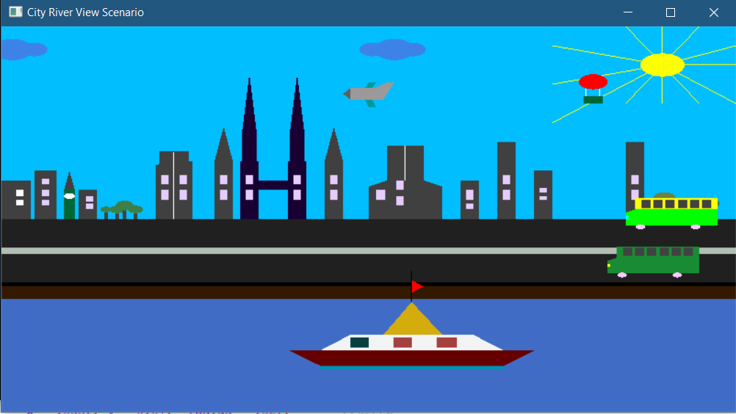

**Night View**

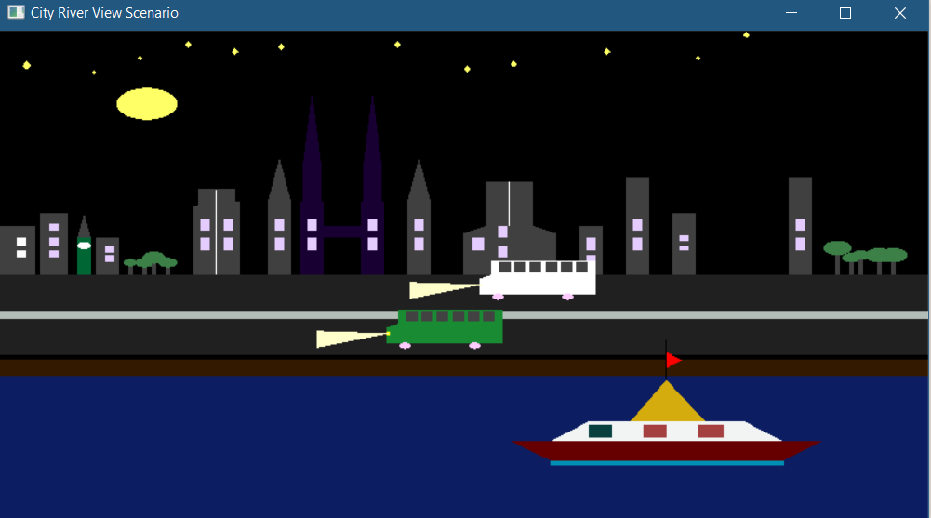

**The project has a view of a city part which is situated by a river. It has both day and night view. In the road there are some transports. By the road side there are some buildings. In the river there are boats and ship in this project.**

**Project background:**

The planning behind this project is making a beautiful city which is situated beside a river.

**Project Impact:**

By doing this project we learn lots of thing. We get different ideas for our project.